BIGQUERY CUSTOMER CHURN

DELIVERABLE 1: DATA INGESTION & TRANSFORMATION ARTIFACTS
Step 1: Sanitized & Partitioned Production Table
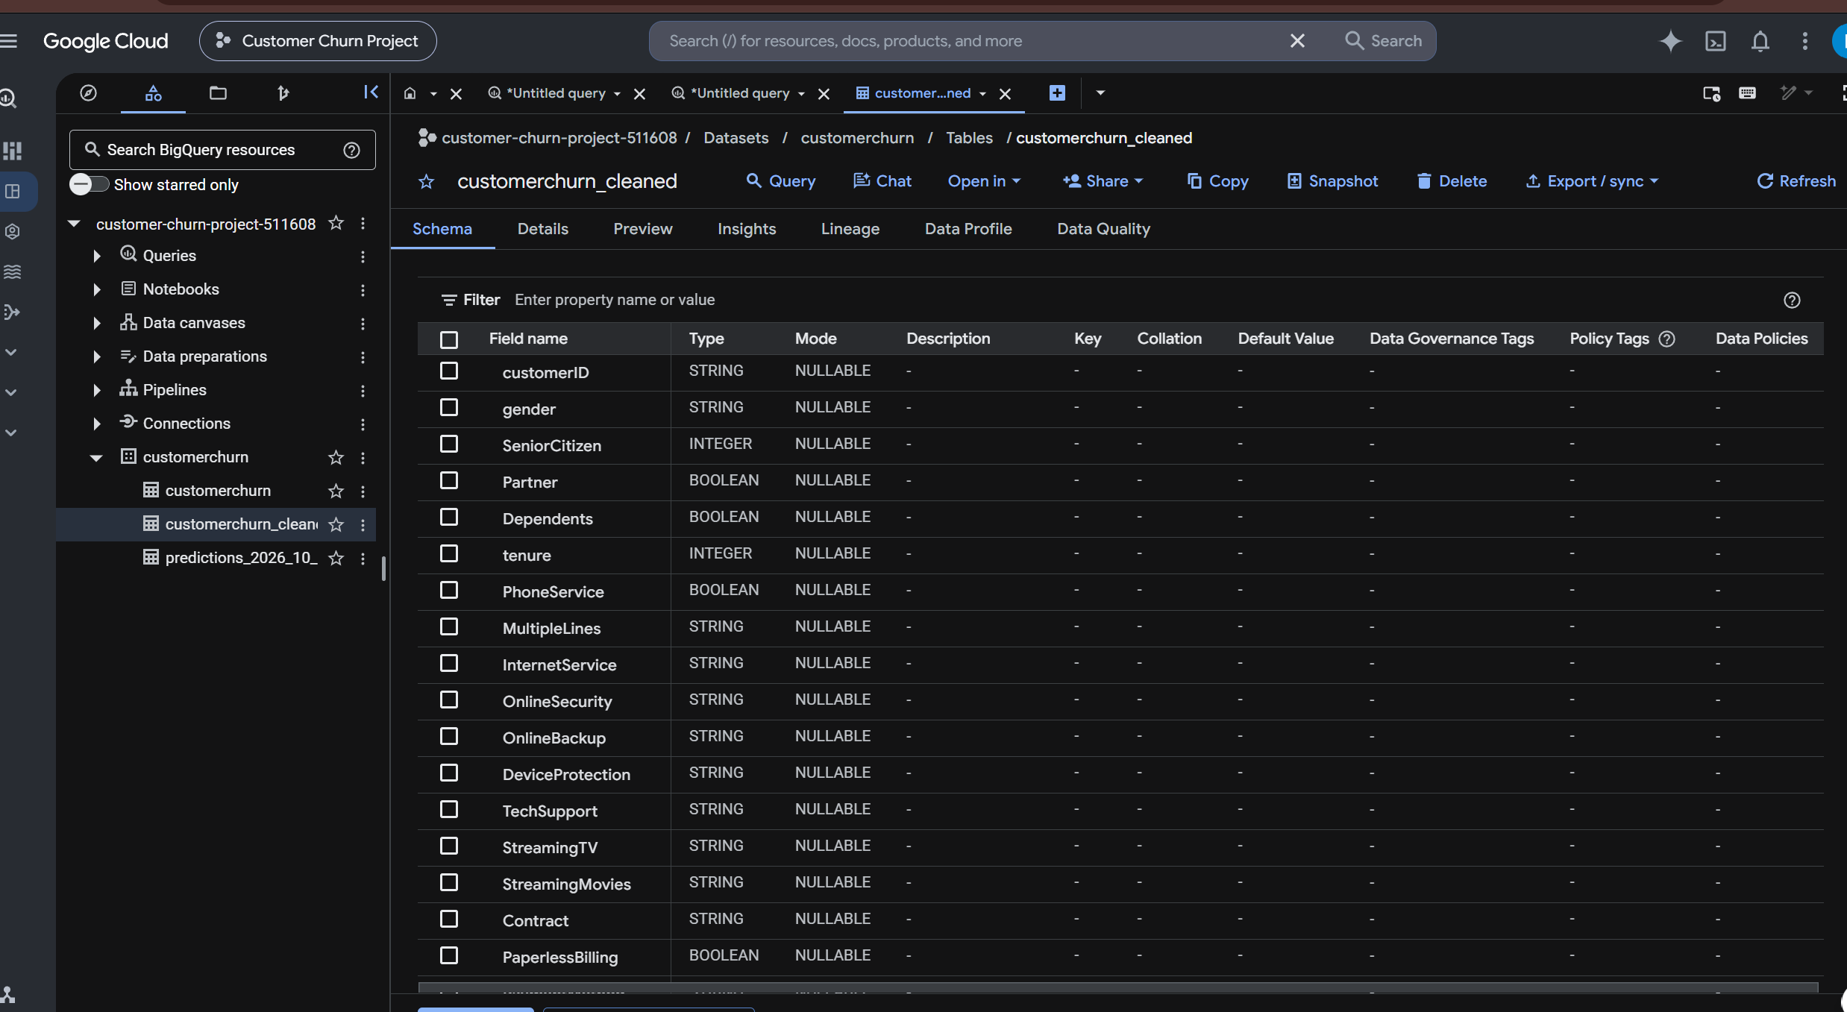
Step 2: EDA
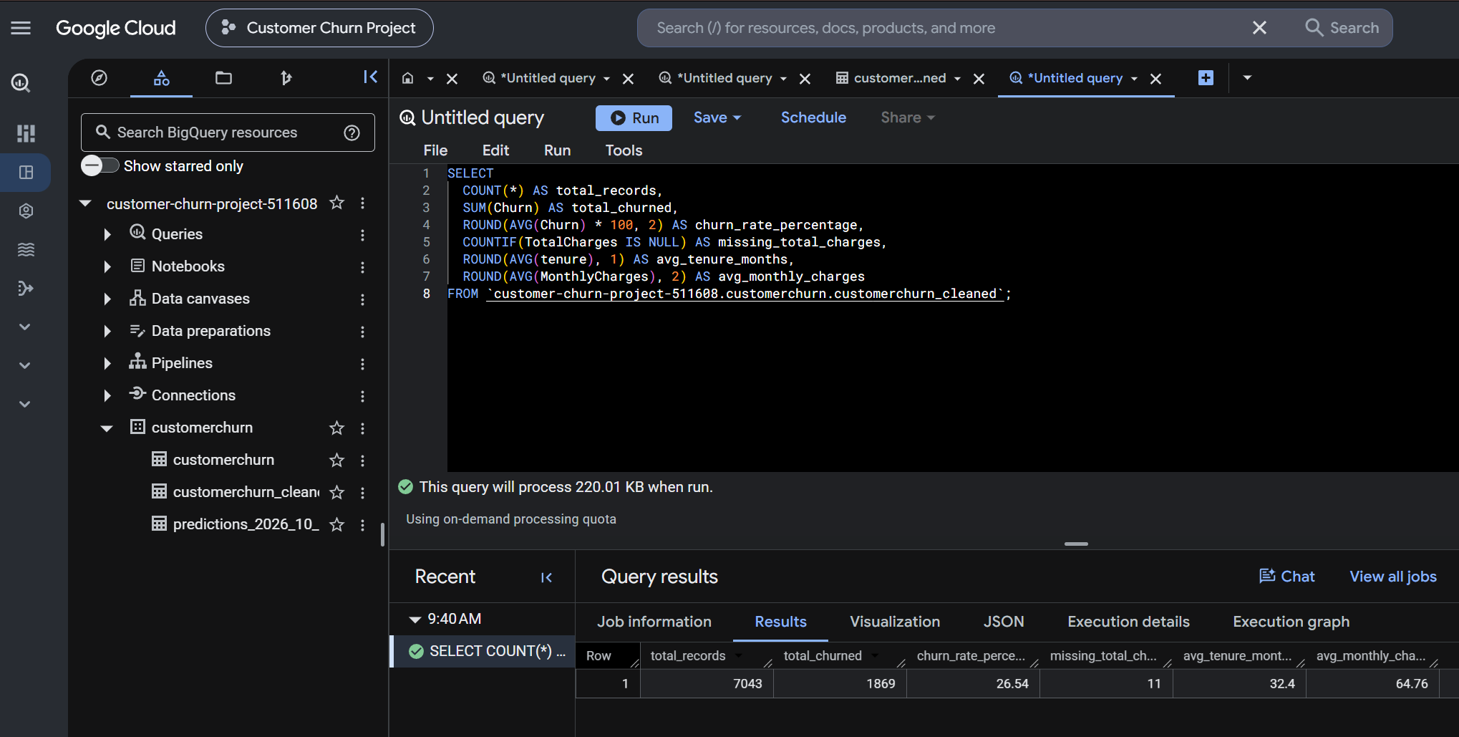
Step 3: Packaged Deliverable 1 Artifacts

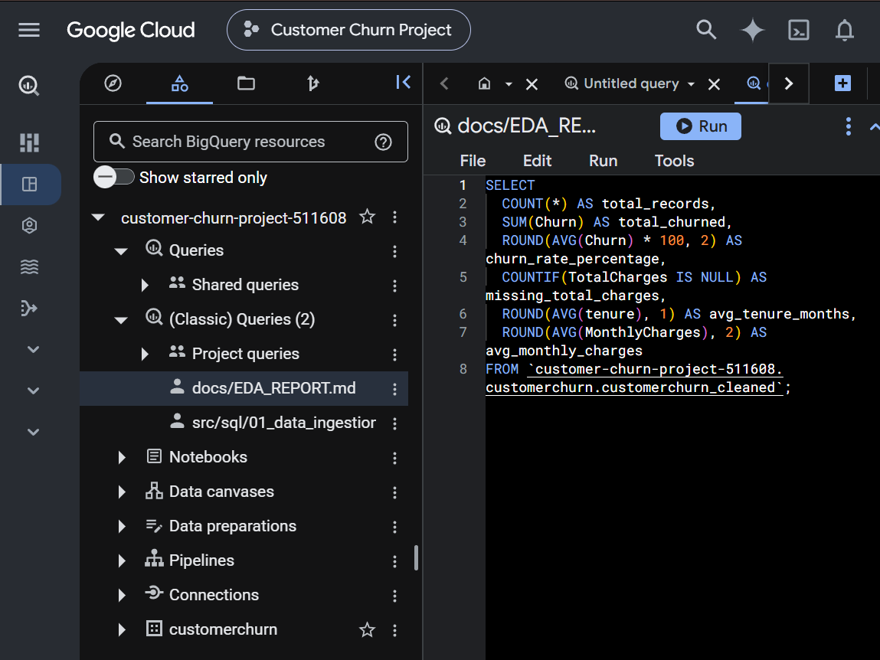

DELIVERABLE 2: MODULAR PIPELINE CODEBASE & ARCHITECTURE DIAGRAM
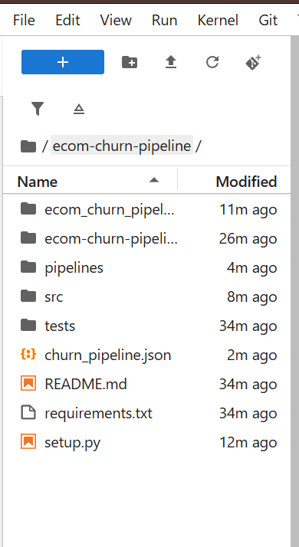

DELIVERABLE 3: MODEL ARTIFACTS & PERFORMANCE REPORT
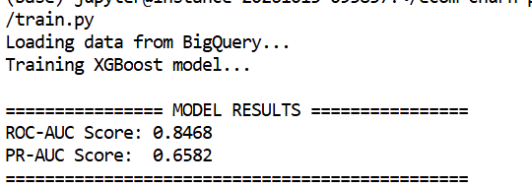

DELIVERABLE 4: INFERENCE ENDPOINTS & SCORING PIPELINES
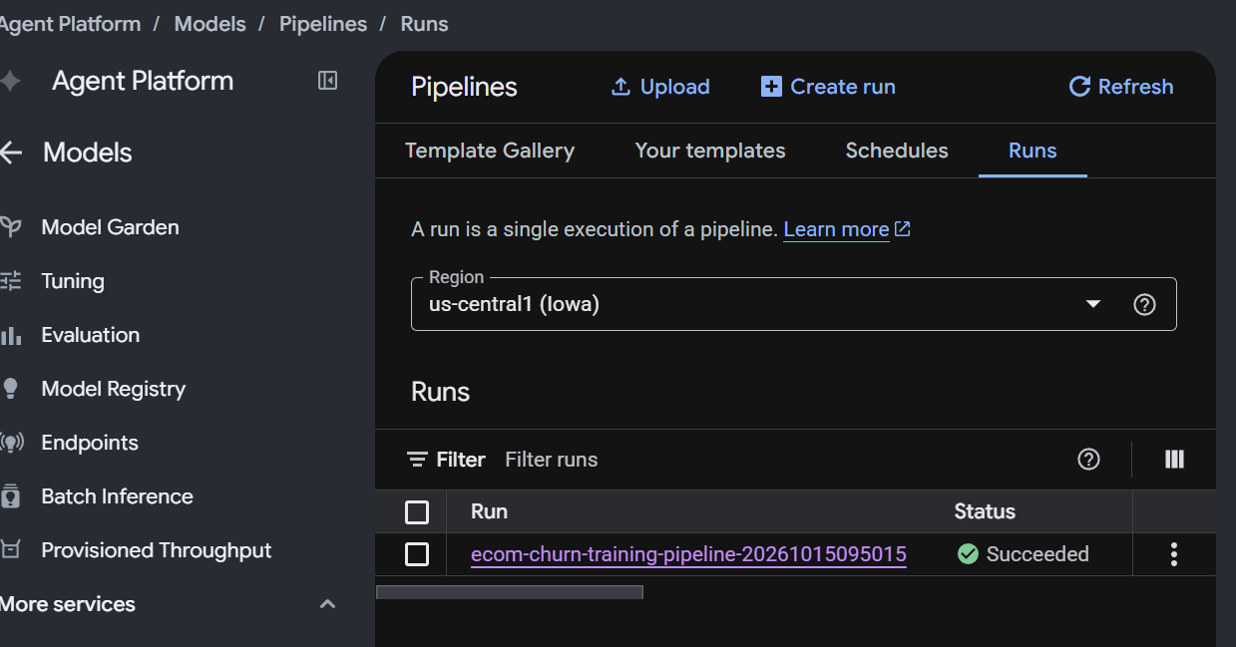
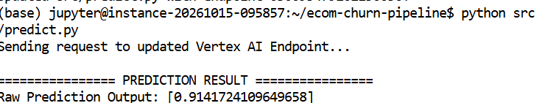

DELIVERABLE 5: MLOPS OPERATIONS MANUAL & MONITORING SETUP


